|  |
| --- |
| User Manual  2022 |
|  |
| March 9  Group 5  Title: Face Recognition System |

Table of Contents

1.0 Introduction 3

2.0 Using the Device 4

2.1 Download the zip folder 4

2.2 Download XAMPP (For who already download XAMPP continues to 2.4) 4

2.3 The XAMPP Control Panel 10

2.4 Starting XAMPP modules 11

2.5 Setup the database 12

2.6 Install Python 16

2.6.1 Install Packages for Python 20

2.7 Using IDE to run program 23

3.0 Introduction for interface and function 24

3.1 Main.py page 24

3.2 Student.py 25

3.2.1 Student.py button function 25

3.3 Face_attendence.py 26

3.4 Train.py 27

3.5 List.py 28

3.5.1 list.py button function 28

4.0 How to use the Software? 29

5.0 What to Do If Unable to Run the Software? 40

# 1.0 Introduction

This project is about the development of “Face Recognition-based Student Attendance Monitoring System for Educational Institutions” by us, a 6-member group. Why do we choose a face recognition system? This is because face recognition is one of the most researched technologies in computer vision, with new techniques and promising findings being published every year. There are various types of face recognition methods and here are some examples:

1. holistic matching,
2. feature-based matching, and
3. hybrid matching.

For the holistic matching approach, the user's entire face is used as the raw input to the recognition system, while the feature-based matching approach extracts the eyes, nose, mouth and features and feeds them into the structural classifier for further processing. Hybrid matching is a combination of holistic matching and feature-based matching approaches. It extracts the features of the face and then converts them into a code. This code will be stored in a database and then compared with the input image for recognition.

# 2.0 Using the Device

## 2.1 Download the zip folder

First, download the packaged code by using the following link with a MMU Gmail: -

<https://drive.google.com/drive/folders/1SZEXG0LgYtGQ2MIf7or3YCY66lcBSD_Q?usp=sharing>

Inside the google drive, there have one zip file named Software, right click the file and select download. After the download finish, extract the zip file to any location.

## 2.2 Download XAMPP (For who already download XAMPP continues to 2.4)

In order to run the software, you have to download the XAMPP so that the database system is usable. Follow the step below to download & install XAMPP.

Step 1: Download

XAMPP is a release made available by the non-profit project Apache Friends. Versions with PHP 7.4.27, 8.0.15 or 8.1.2 are available for download on the [Apache Friends](https://www.apachefriends.org/download.html) website. Choose the correct download that match your platform.

Step 2: Run .exe file

Once the software bundle has been downloaded, you can start the installation by double click on the file with the ending .exe. Example name of the PHP 8.0.15, “xampp-windows-x64-8.0.15-0-VS16-installer.exe”

Step 3: Deactivate any antivirus software

Since an active antivirus program can negatively affect the installation process, it’s recommended to temporarily pause any antivirus software until all XAMPP components have successfully been installed.

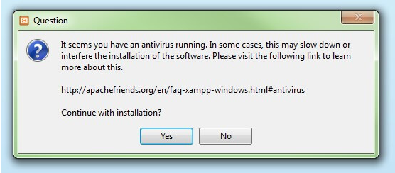

Before installing XAMPP, it is advisable to disable the anti-virus program temporarily

Step 4: Deactivate UAC

User Account Control (UAC) can interfere with the XAMPP installation because it limits writing access to the C: drive, so we recommend you deactivate this too for the duration of the installation process. To find out how to turn off your UAC, head to the [Microsoft Windows support pages](https://support.microsoft.com/en-us/windows/protect-my-pc-from-viruses-b2025ed1-02d5-1e87-ba5f-71999008e026).

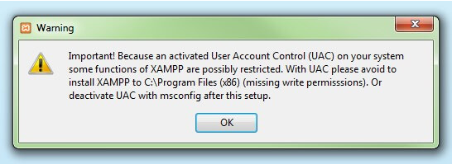

User account control can affect the installation of XAMPP

Step 5: Start the setup wizard

After you’ve opened the .exe file (after deactivating your antivirus program(s) and taken note of the User Account Control, the start screen of the XAMPP setup wizard should appear automatically. Click on ‘Next’ to configure the installation settings.

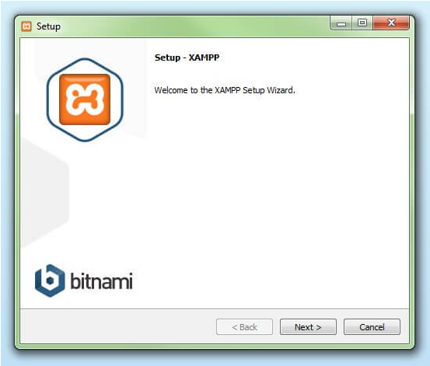

You can start the setup on the start-up screen

Step 6: Choose software components

Under ‘Select Components’, you have the option to exclude individual components of the XAMPP software bundle from the installation. But for a full local test server, we recommend you install using the standard setup and all available components. After making your choice, click ‘Next’.

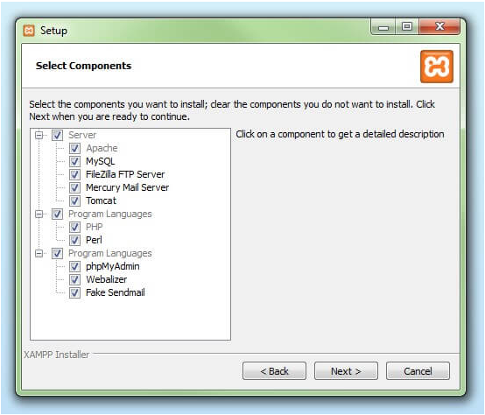

In the dialog window entitled 'select components', you can

choose the software components before installation

Step 7: Choose the installation directory

In this next step, you have the chance to choose where you’d like the XAMPP software packet to be installed. If you opt for the standard setup, then a folder with the name XAMPP will be created under C:\ for you. After you’ve chosen a location, click ‘Next’.

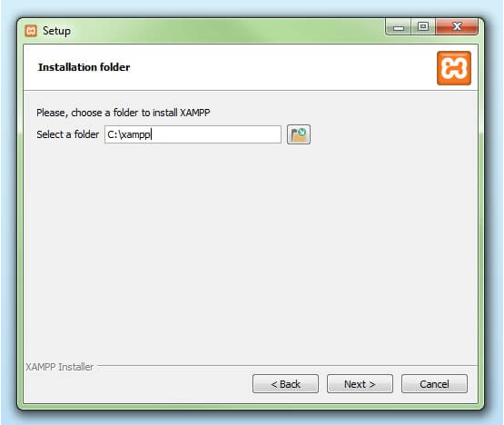

For the next step, you need to select the directory where XAMPP should be installed

Step 8: Start the installation process

Once all the aforementioned preferences have been decided, click to start the installation. The setup wizard will unpack and install the selected components and save them to the designated directory. This process can take several minutes in total. You can follow the progress of this installation by keeping an eye on the green loading bar in the middle of the screen.

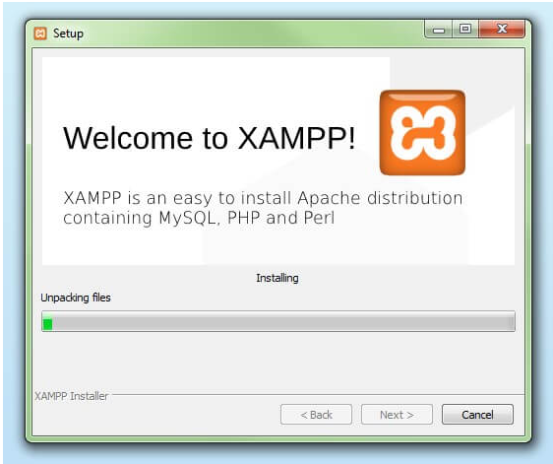

According to the default settings, the selected software

components are unpacked and installed in the target folder

Step 9: Windows Firewall blocking

Your Firewall may interrupt the installation process to block some components of the XAMPP. Use the corresponding check box to enable communication between the Apache server and your private network or work network. Remember that making your XAMPP server available for public networks isn’t recommended.

Step 10: Complete installation

Once all the components are unpacked and installed, you can close the setup wizard by clicking on ‘Finish’. Click to tick the corresponding check box and open the XAMPP Control Panel once the installation process is finished.

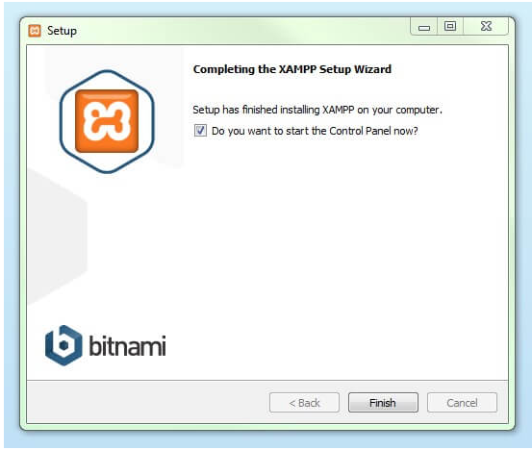

By clicking on 'finish', the XAMPP Setup Wizard is completed

## 2.3 The XAMPP Control Panel

Controls for the individual components of your test server can be reached through the XAMPP Control Panel. The clear user interface logs all actions and allows you to start or stop individual modules with a single. The XAMPP Control Panel also offers you various other buttons, including:

* Config: allows you to configure the XAMPP as well as the individual components
* Netstat: shows all running processes on the local computer
* Shell: opens a UNIX shell
* Explorer: opens the XAMPP folder in Windows Explorer
* Services: shows all services currently running in the background
* Help: offers links to user forums
* Quit: closes the XAMPP Control Panel

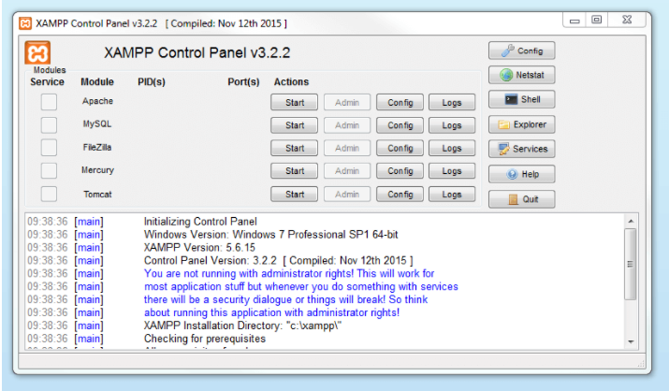

In the Control Panel, you can start and stop individual modules

## 2.4 Starting XAMPP modules

Individual modules can be started or stopped on the XAMPP Control Panel through the corresponding buttons under ‘Actions’. You can see which modules have been started because their names are highlighted green under the ‘Module’ title.

In order to run the current project, Apache and MySQL is enough.

Press Start button under the Actions column for Apache and MySQL.

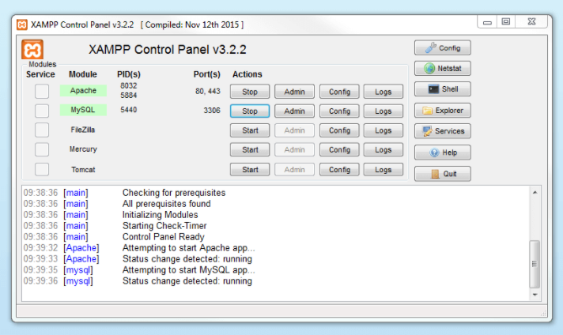

An active module is marked in green in the Control Panel

## 2.5 Setup the database

After Apache and MySQL in XAMPP is running, you will need to navigate to the browser and access to localhost to import the SQL file(face_attendance.sql). The SQL file can be found in the folder extract before.

You can access to localhost by clicking the Admin button in the same row with MySQL or manually enter the link: <http://localhost/phpmyadmin>

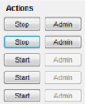

Admin button located besides Stop

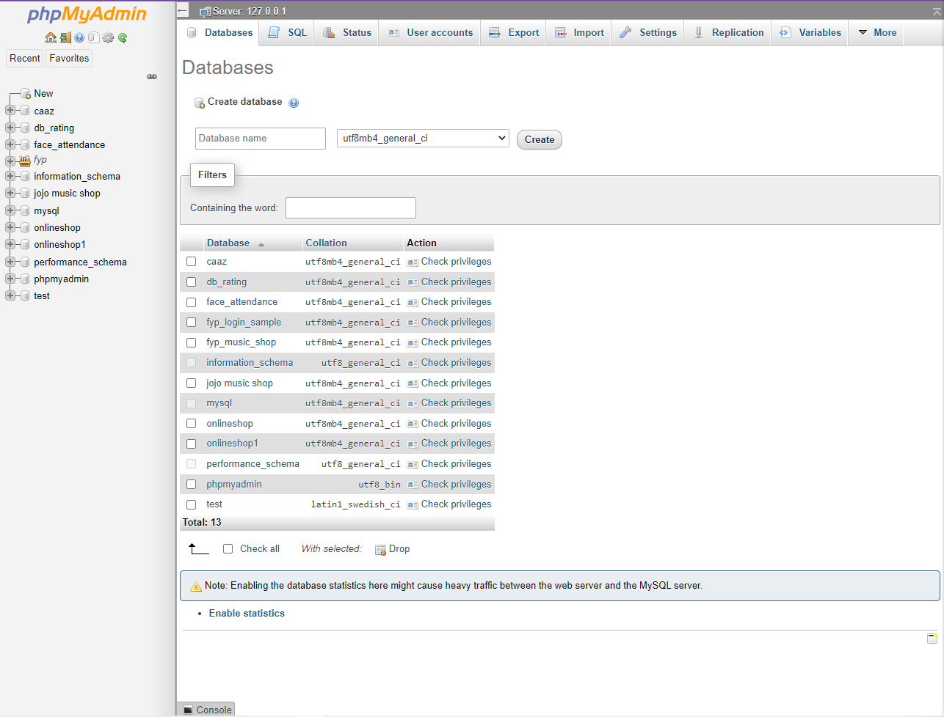 The main page of localhost

After you had reach the phpMyAdmin, click on the Database tab. Now you should see the option to Create a Database and input field to enter the database name. Write the database name as “face_attendance” and hit the ‘Create’ button. You will see a success message in a while.

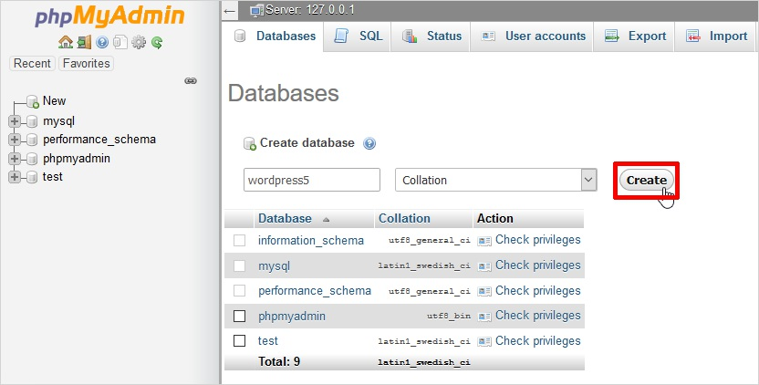



The SQL File

After you had successfully created the database, you can start to import the SQL file to the face_attendance database by following the steps below. The SQL file can be located at the same folder of the extracted zip file and it is named “face_attendance.sql”.

Step 1: Select the destination database on the left pane.

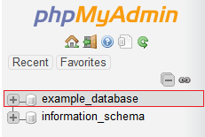

Step 2: Click on the Import tab in the top center pane.

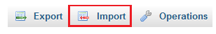

1. 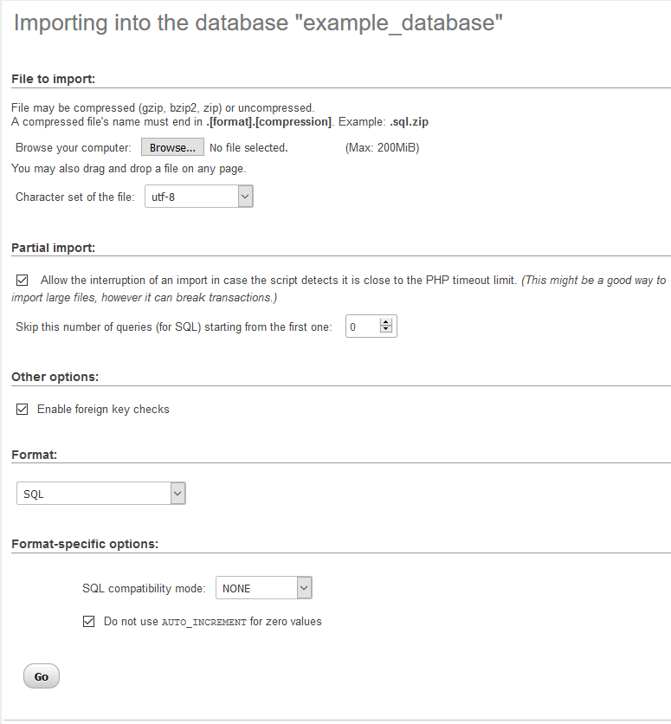Under the File to import section, click Browse and locate the file with the .sql extension you wish to import.
2. Ignore the option for 'Partial import' and 'Other options'.
3. From the Format dropdown menu choose 'SQL'.
4. Click the Go button at the bottom to import the database.

If you successfully imported the SQL file, the newly-imported table will appear in the list of tables.

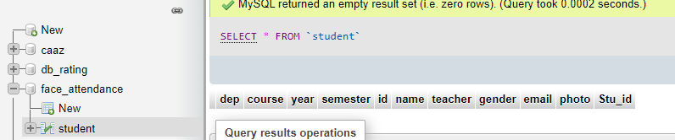This is the database look like

And you have done with the setup of database.

## 2.6 Install Python

If you had python version equal or greater than 3.7 installed in your device, you may skip to “2.6.1 Install Packages for Python” to install the required packages.

Else, follow the following steps to install python on your device.

Official Python download link: <https://www.python.org/downloads/>

Step 1 − Select Version of Python to Install

Python has various versions available with differences between the syntax and working of different versions of the language. We need to choose the version which we want to use or need. There are different versions of Python 2 and Python 3 available.

Step 2 − Download Python Executable Installer

On the web browser, in the official site of python (www.python.org), move to the Download for Windows section.

All the available versions of Python will be listed. Select the version required by you and click on Download. Let suppose, we chose the Python 3.9.1 version.

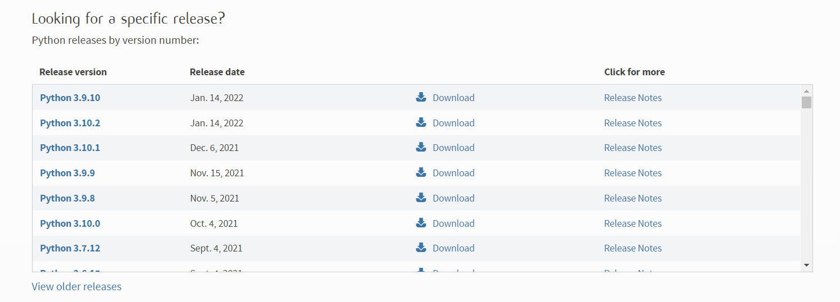

On clicking download, various available executable installers shall be visible with different operating system specifications. Choose the installer which suits your system operating system and download the installer. Let suppose, we select the Windows installer (64 bits).

The download size is less than 30MB.

Step 3 − Run Executable Installer

We downloaded the Python 3.9.1 Windows 64-bit installer.

Locate and run the installer. Make sure to select both the checkboxes at the bottom and then click Install New.

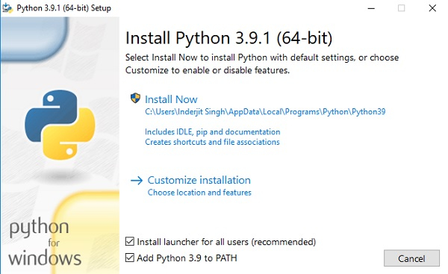

On clicking the Install Now, the installation process starts.

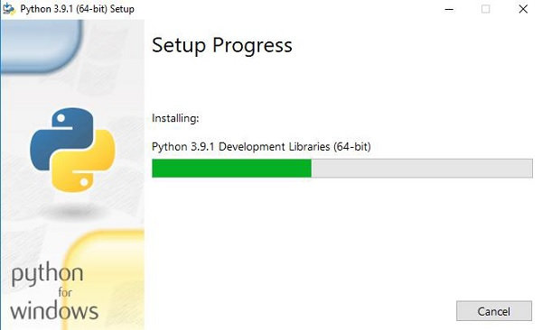

The installation process will take few minutes to complete and once the installation is successful, the following screen is displayed.

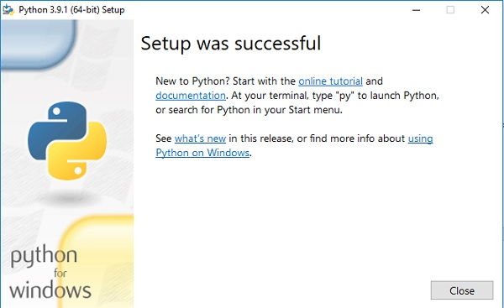

Step 4 − Verify Python is installed on Windows

To ensure if Python is successfully installed on your system.

Follow the given steps −

* Open the command prompt. (You can refer to “2.6.1 Install Packages for Python” on how to open the command prompt)
* Type ‘python’ and press enter.
* The version of the python which you have installed will be displayed if the python is successfully installed on your windows.

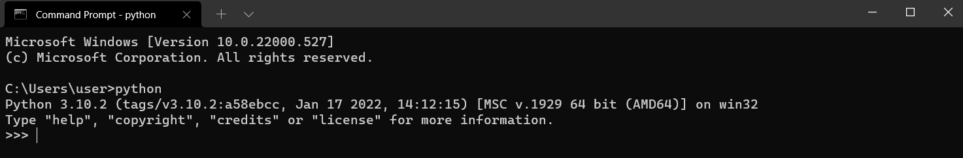

Example of Python 3.10.2 installed

Step 5 − Verify Pip was installed

Pip is a powerful package management system for Python software packages. Thus, make sure that you have it installed.

To verify if pip was installed, follow the given steps −

* Open the command prompt.
* Enter pip –V to check if pip was installed.
* The following output appears if pip is installed successfully.

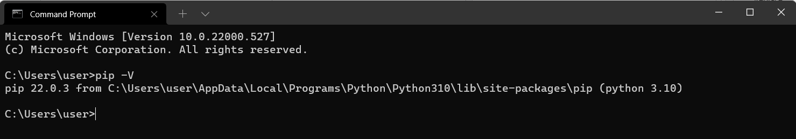

And now you have successfully installed python and pip on Windows system.

## 2.6.1 Install Packages for Python

First, you need to open Command Prompt. There are few ways to open the Command Prompt.

1. Open through Search

You can search the Command Prompt in the search by entering cmd or Command Prompt. Click Open.

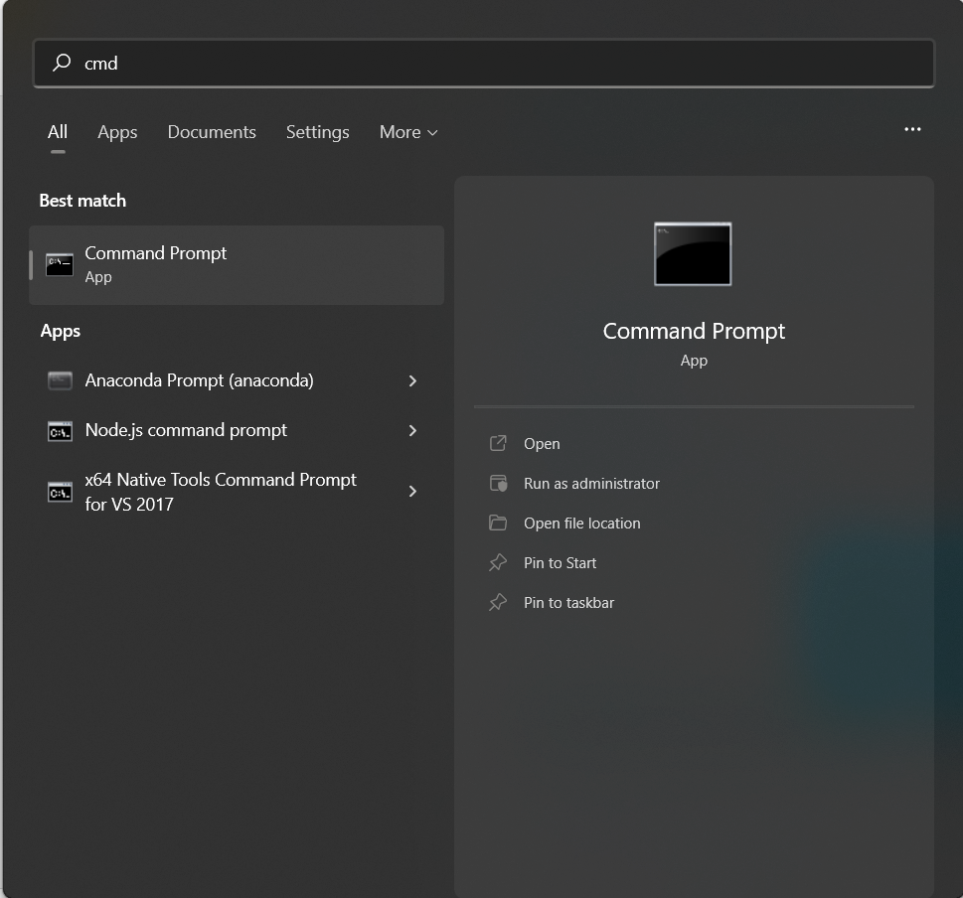

2. Open through Run

Press “Windows + R” to open “Run” box. Type “cmd” and then click “OK” to open a regular Command Prompt. Type “cmd” and then press Ctrl+Shift+Enter to open an administrator Command Prompt.

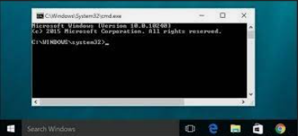

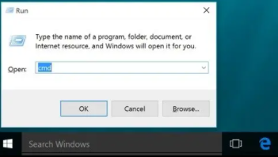

Required Packages

After the command prompt is open, type or copy the following command into the command prompt to install the required package for python.

* pip install pillow
* pip install tk
* pip install mySQL-connector-python
* pip install pymysql
* pip install opencv-python
* pip install opencv-contrib-python

If Using on Anaconda

Remember to run the command above in Anaconda Prompt but not windows command prompt!

For the user who use jupyter notebook or spyder you can direct install the package at the compiler.

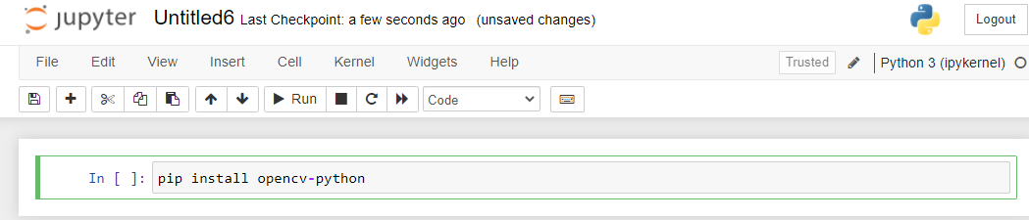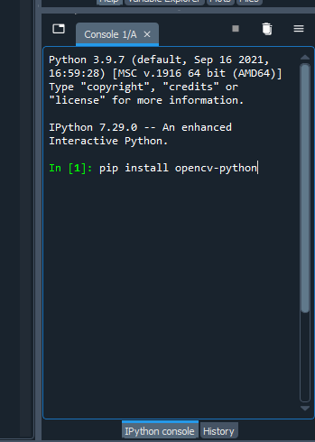

Jupyter(compiler)

Spyder(compiler)

## 2.7 Using IDE to run program

When you have done setting up the database and install all the required package, you can use any IDE that support python to run the software/system.

Some recommended IDE

* Visual Studio Code
* Jupyter Notebook
* Spyder

If the zip file is extracted correctly, the file content should be like the picture below.

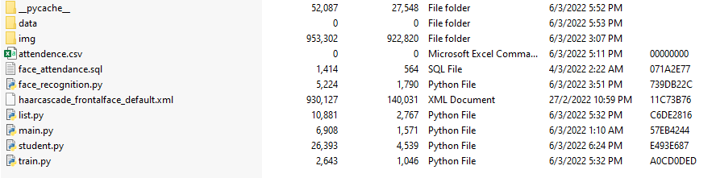

All the file inside the folder

Troubleshooting for some IDE

When running python file on some IDE, it does not locate the file with the actual location of the file while it run in the python work directory. So, you might need to tweak some setting of the IDE.

For example, here is the way of setup the setting of VisualStudio Code.

1. In your VSCode for Windows
2. File --> Preferences --> Settings --> (User)Extensions --> Python -->
3. Terminal: Execute In File Dir --> Check It
4. or
5. File --> Preferences --> Settings --> Search Settings --> python.terminal.executeInFileDir

# 3.0 Introduction for interface and function

## 3.1 Main.py page

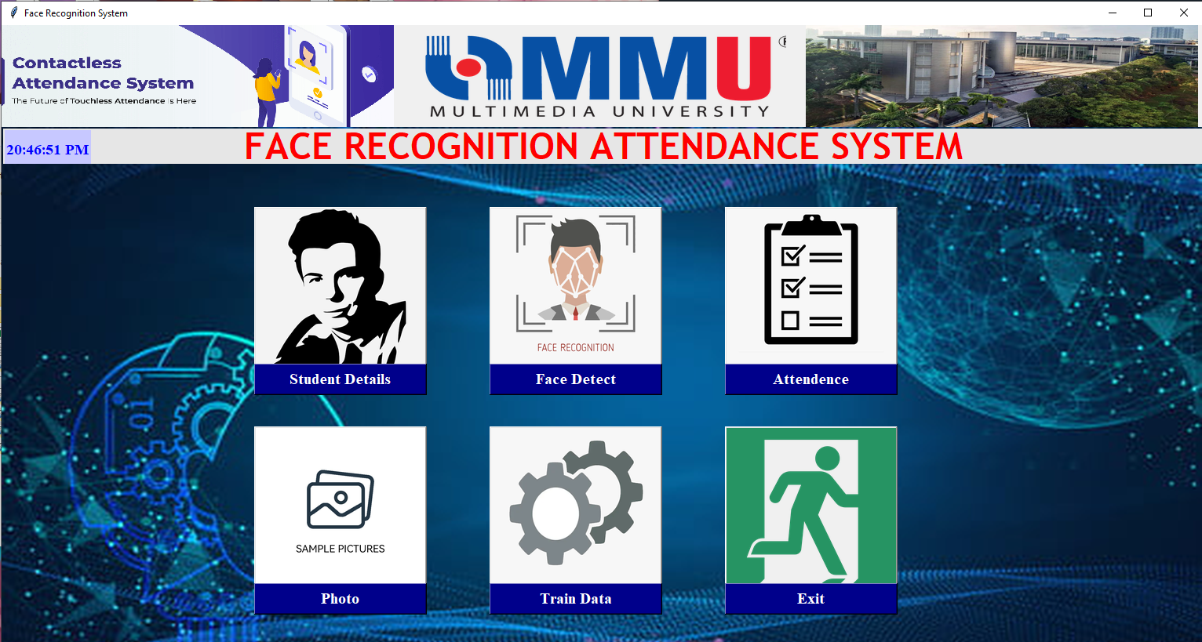

This button is use to exit the program

This button that uses for view the photo that taken by user

The button that link with train.py file

The button that link with list.py file

The button that link with face_reconition.py file

The button that link with student.py file

## 3.2 Student.py

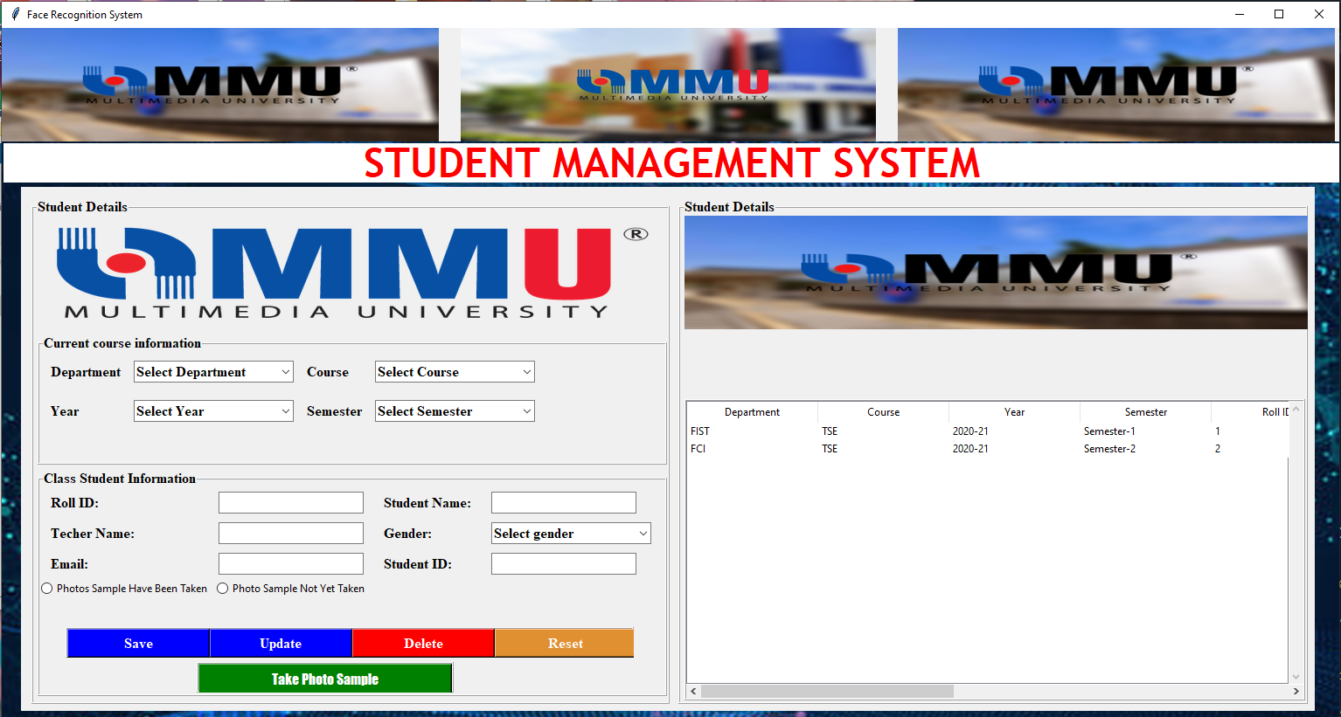

Class student information is use for record the student information

This table is use for display the detail that record for the user and the user can select the detail at this table use for edit the detail

Current course information is use for record the student course information

### 3.2.1 Student.py button function

* Save button:
  + Use to register the new student and save all the information that key in by user.
* Update button:
  + Use to update the information for the register or student, but the user need select the information from the table at right hand side, after that user can edit the detail information and update it.
* Delete button:
  + Use to delete the information for the register or student, but the user need select the information from the table at right hand side, after that the selected student detail is deleted.
* Reset button:
  + Reset the information at the Current course informant and class student information entry to be blank
* Take Photo Sample button:
  + Take 100 sample photo for the register or student, it will be used for face recognition.

## 3.3 Face_attendence.py



This button is use to open the camera and recognize the student face

It will open the camera and start to detect the face whether he/ she is registered and will automatically recorded as attended if the student is registered and taken the sample photo.

## 3.4 Train.py

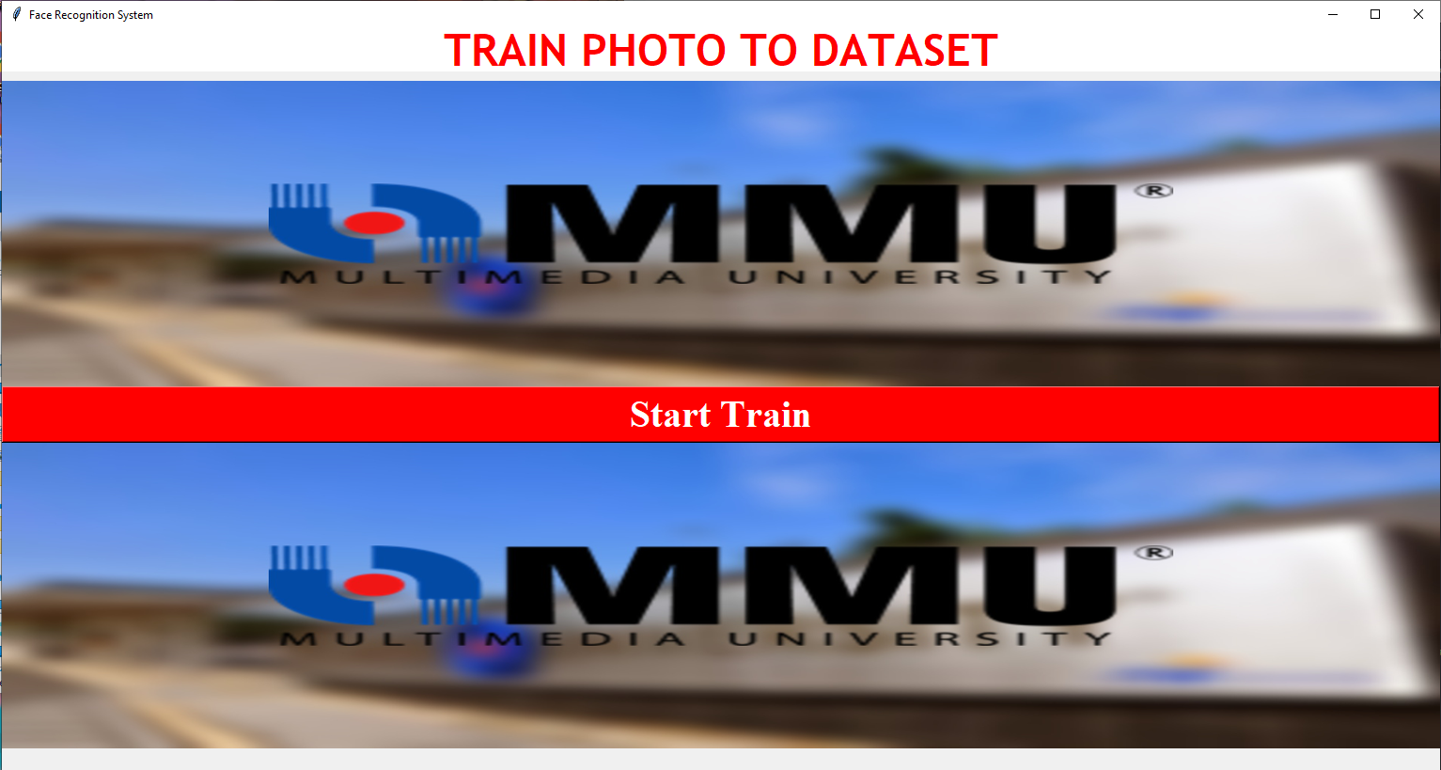

This button is use to train the photo to be data and let the system read use to recognize the student or register face

## 3.5 List.py

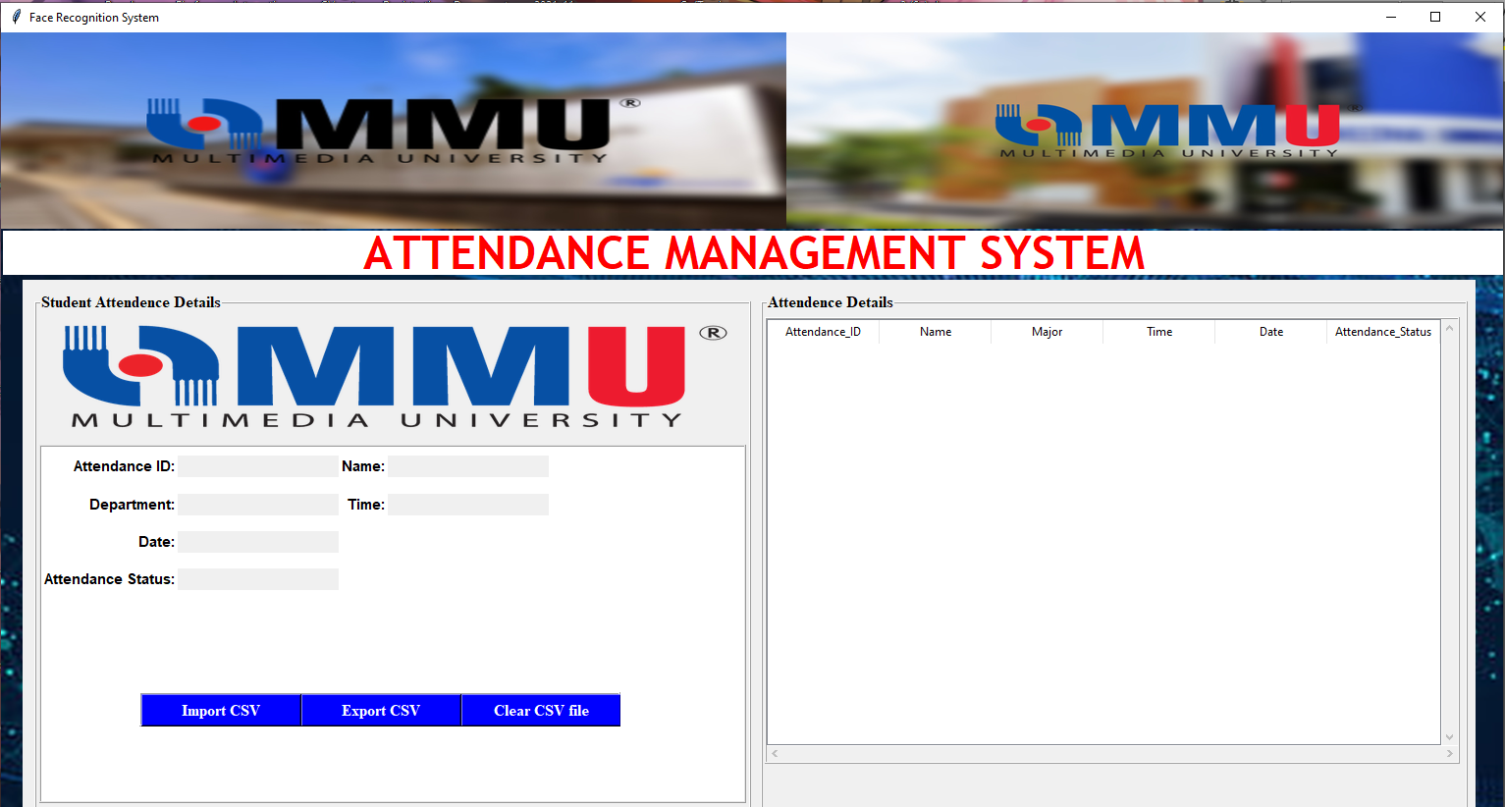

This place is to view the detail of the attendance

This table is use to view all the record by face detect attendance list, but need to import the CVS file first

### 3.5.1 list.py button function

1. Import CSV:
   1. This button is use to import the CVS file for the folder.
2. Export CSV:
   1. This button is use to Export the CSV file for the original CSV file.
3. Clear CSV file:
   1. This button is use to clear the original CSV file and ready to save new record

# 4.0 How to use the Software?

Before your start to run the program please make sure your have understand part 2.0 to the end of part 3.0.

Step 1: Run the main.py

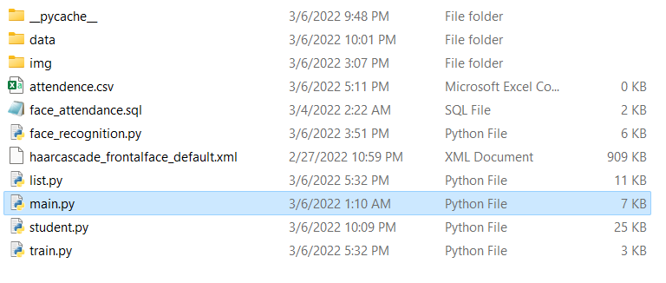

First, run the main.py by double clicking or open it in any IDE that support python. For the IDE, after open main.py, run the file and after few second, the main panel for the system will appear.



First, click on the “Student Details” button or logo to register the information of student or user.

Step 2: Register the student information



Key in the information in all blank entry or choose answer from the dropdown list.

For register, the user/student need to enter same answer for Roll ID and student ID and select “Photo Sample Not Yet Taken”.

*Roll ID must be same with the student ID.



When you have done entering all the information, click the save button.

*For new student, please select the selection “Photo Sample Not Yet Taken”. 

After that, you can view the detail at the right-hand side table.



Next, select the student that you want to take the photo sample.

Click the “Take Photo Sample” button. It will open the camera and take 100 sample photos of the current user/student.

Step 2: Check the Photo



Before training the data, you may check the photo that you take by clicking Photo at main panel.

Step 3: Train Data



After done checking the photo, you can start to train the photo to be data by clicking the “Train Data” button or logo.



Click the start train button to train the photo into dataset.

Step 3: Start face detect



After the data trained complete, click the “Face Detect” button to start the face recognition function.



Press the “Face Recognition” button to open the camera. It will start to detect the user or student’s face and it will auto record the information based on the detail that you have record at student detail.

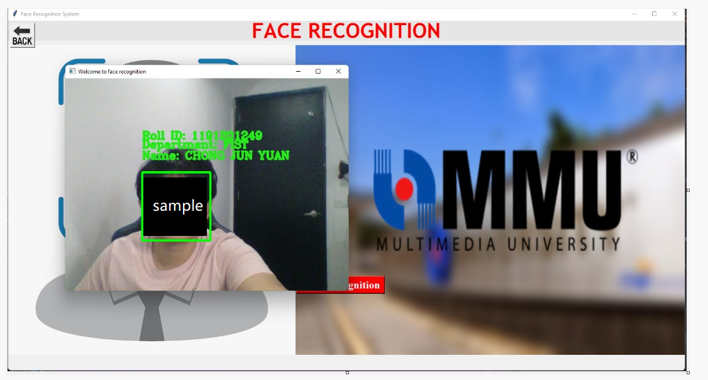

If the face is successfully detected, it will show the green frame around the face and show the detail of the detected student.

*After that, press “Enter” to close the face detection window.

Step 4: Check Register or Student attendance



After closing the face detect panel, you may continue to check if the attendance being recorded.

Click “Attendance” button to check the attendance.



Frist, you need to import the attendance.csv file into this system.

The attendance.csv file can be found at the same folder where the main.py and other .py file located.



After you import the attendance.csv into the system, you may view the attendance detail at the right-hand side table.



You can also export the attendance.csv file to be a new csv file.



When you done export the csv file, you need to clear up the attendance.csv file. And it is ready for new data to be store in the attendance.csv file.

Step 5: End the software



Last, you can click the “Exit” button or logo to end or exit the program.

# 5.0 What to Do If Unable to Run the Software?

First, check if you had added python to Windows path.

Navigate to the Windows Environment Variables screen

To navigate to the Windows Environment Variables screen (where you can add/edit your paths):

* Press the Windows Key + R on your keyboard in order to open the Run dialog box
* Type sysdm.cpl to open the System Properties
* Go to the Advanced tab and then click on the ‘Environment Variables…’
* That should take you to the Environment Variables screen, where you can add/edit your paths.

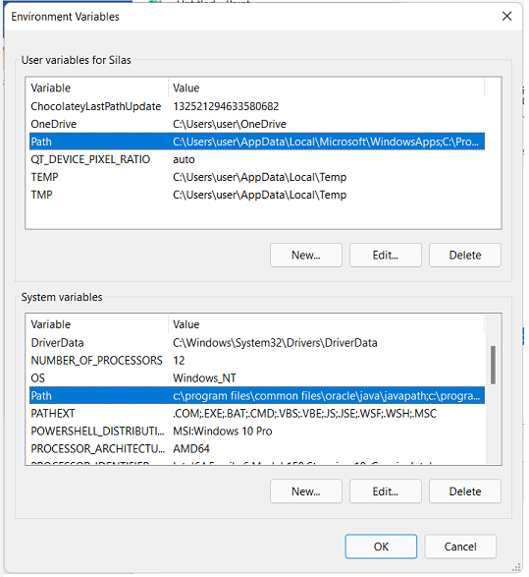

* Double click on Path to check if the directory of python had been added.

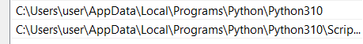

* If there is no, follow the step below to add.

Step 1: Navigate to the Windows Environment Variables screen

To navigate to the Windows Environment Variables screen (where you can add/edit your paths):

* Press the Windows Key + R on your keyboard in order to open the Run dialog box
* Type sysdm.cpl to open the System Properties
* Go to the Advanced tab and then click on the ‘Environment Variables…‘

That should take you to the Environment Variables screen, where you can add/edit your paths.

If there are path but does not contain python directory inside it, follow the steps below or if there are no Path under the variable, skip to next part of tutorial.

* Before adding the path, we need to find the location of where python installed.
* 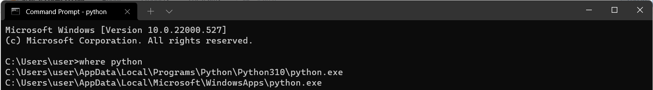
* Open Command Prompt and type or copy the command:
  + where python
* Copy the python directory until …Python310 (the number changes with version of python)
  + For example, C:\Users\user\AppData\Local\Programs\Python\Python310
* Follow the following steps to add the python directory to Path.

1. Click on Path and click ‘Edit…’.

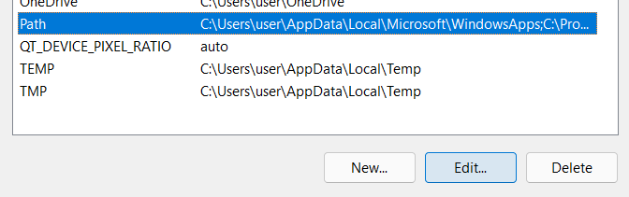

1. Click the ‘New…’ to add new directory,

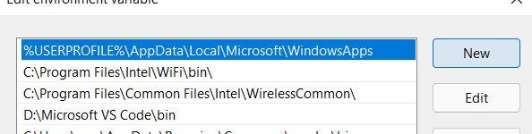

1. In the entry, paste the directory of the python copied above.



1. After paste or type the python directory, press ‘Ok’ and repeat the steps above with the other Path under the System Variable.

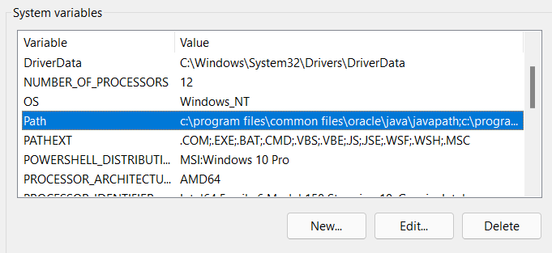

1. Press ‘Ok’ after done setup and retry from step “2.6.1 Install Packages for Python”.

If there are no Path under the variable, follow the steps below.

1. Click on ‘New…’ to add the ‘Path’ variable (note that if your ‘Path’ variable already exists, then click on ‘Edit…’ instead):

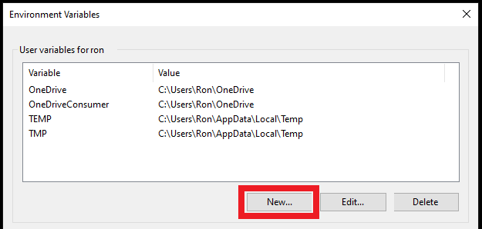

1. You should then see the following box, where you may add/edit variables:

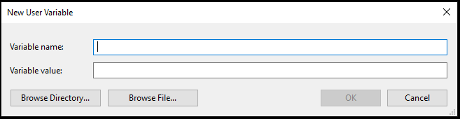

1. Before you type any values, you’ll need to locate the relevant Python paths. The paths that you’ll need to get are:

* The Python application path, which is the folder where you originally installed Python; and
* The Python Scripts path. The Scripts folder should be located within the Python application path.

1. Here is how my Python application path looks like:

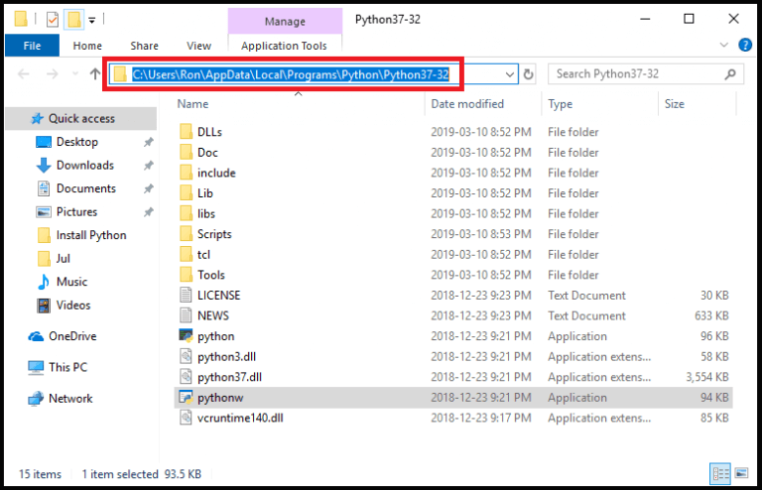

And this is how my Python Scripts path looks like:

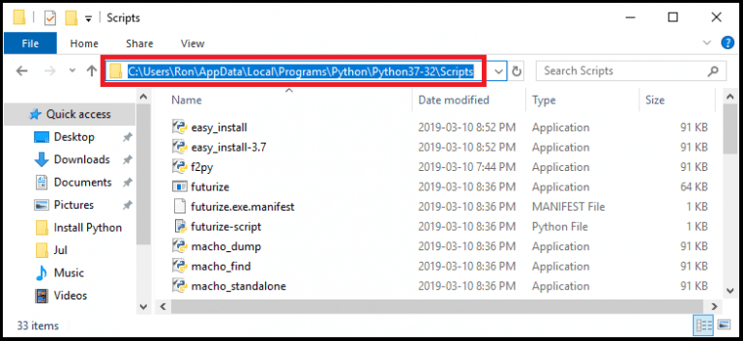

1. Now let’s fill the New User Variable box that you saw earlier:



1. For the Variable name, type ‘Path‘.

For the Variable value, copy the full Python application path, then use semicolon (as highlighted in yellow below), and finally copy the Python Scripts path.

This is how my Variable value looks like:

C:\Users\Ron\AppData\Local\Programs\Python\Python37-32;C:\Users\Ron\AppData\Local\Programs\Python\Python37-32\Scripts

1. Put all the values together in the New User Variable box:

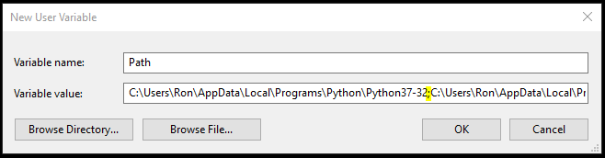

1. Press ‘OK’ and you would then see your new Python Path under the ‘User variables’ section. Don’t forget to press ‘OK’ again so that the changes will get implemented.

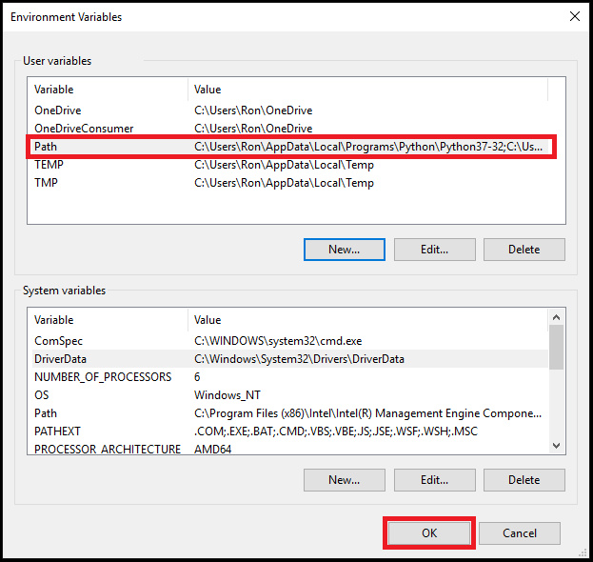

1. That’s it! You just added Python to the Windows Path.

If the steps provided above doesn’t solve the issue, you may try to reinstall the Python.

Full Uninstall of Python

* Uninstall all instances of Python (Control Panel\Programs\Programs and Features, search Python)
* Remove Python from your path (System properties > environment variables... > click on path at the top, edit, delete any references in the list to python)
* Delete any remaining files (go to C:\Users\%USERNAME%\AppData\Local\Programs\Python and delete any files/folders inside)
* After uninstall the python, proceed to “2.6 Install Python”